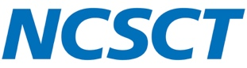
Standard Treatment Programme Feedback Form

The Standard Treatment Programme for the NHS Community Pharmacy Smoking Cessation Service (SCS) has been published via a rapid development process to make sure that it was available for the launch of this service.
If you have any corrections, suggestion or comments about the STP
then we would be very grateful if you could use this form.
Please submit this form to: enquiries@ncsct.co.uk
General comments:

Page number | Corrections, suggestions and comments

Thank you.

